September 2021

Lumen Static IP Process

Table of Contents
0
Creating the Static IP addresses 2
Central & Eastern Markets (legacy EQ/CT territory) 2
Static IP Validation 6
Central & Eastern Markets (legacy EQ/CT territory) 6
Western Markets (legacy Q territory) 10
Moving Locations and Static IP Impacts 17
Central & Eastern Markets (legacy EQ/CT territory) 17
Western Markets (legacy Q territory) 18

Creating the Static IP addresses
Please pay careful to attention to which market you order from.
- Central and Eastern Markets (legacy EQ/CT territory) orders and provisions Static IPs through the EASE ordering system and the LSR.
- Western Markets (legacy Q territory) must call the Repair Help Desk at 800-223-7881 instead of utilizing Qwest.Net. This is for adding, change, or removal of Static IP.
- Assistance - Contact your assigned CSM. For further assistance contact the Wholesale Systems Help Desk at 888-796-9102 Opt 3.

Central & Eastern Markets (legacy EQ/CT territory)
Place your WBSA order through the EASE system.
Select the Product Catalog at the following link: https://www.centurylink.com/wholesale/pcat/wbsaresale.html
Look for the “Pricing and Ordering Codes” section and select the link that says, “Available service offerings and ordering codes can be found here.”

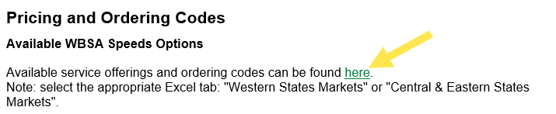

An Excel sheet will open with two tabs. Select the “Central and Eastern States (EASE)” tab and review the Static IP codes.
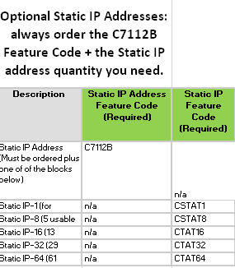

Place your order with the codes for Static IP.
The LSR feature code C7112B is required for all Static IP orders. It must be on LSR PON and then add feature for the number IP's.
A Static IP address is created after FOC. For reference, Static IPs are only available for BUS customer orders. You can find the Product Guide at https://www.centurylink.com/wholesale/ctl/wbsa.html
For further help on this section, CenturyLink has created a training document that will walk a customer through the EASE ordering process. The following screen shots will show what to expect. An online simulation is available as well.
Type “Lumen.com/wholesale” into your browser and visit “Quick Links” and then “CenturyLink QC Region”

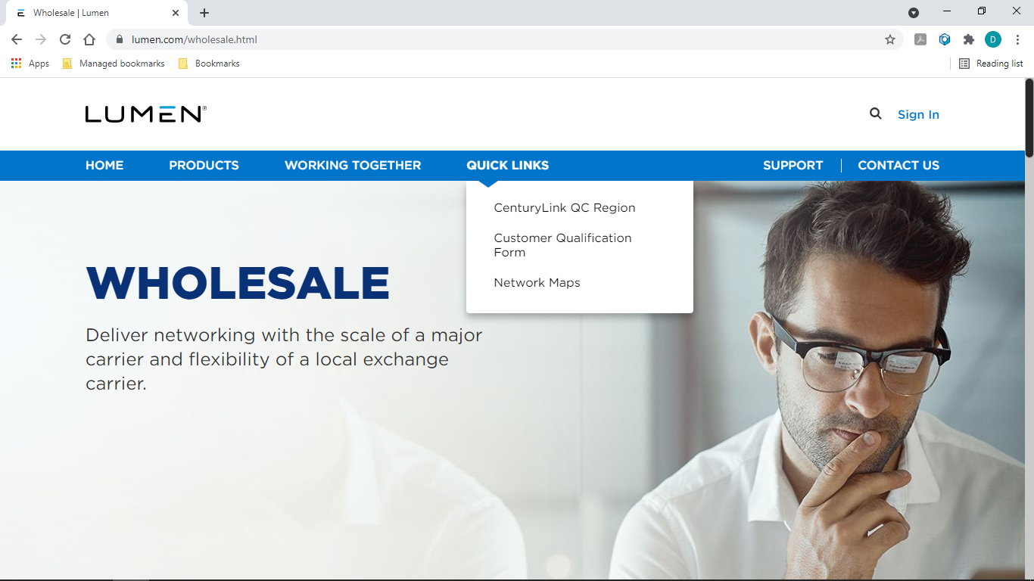

Visit the “CenturyLink Region” section then “Customer Service”.
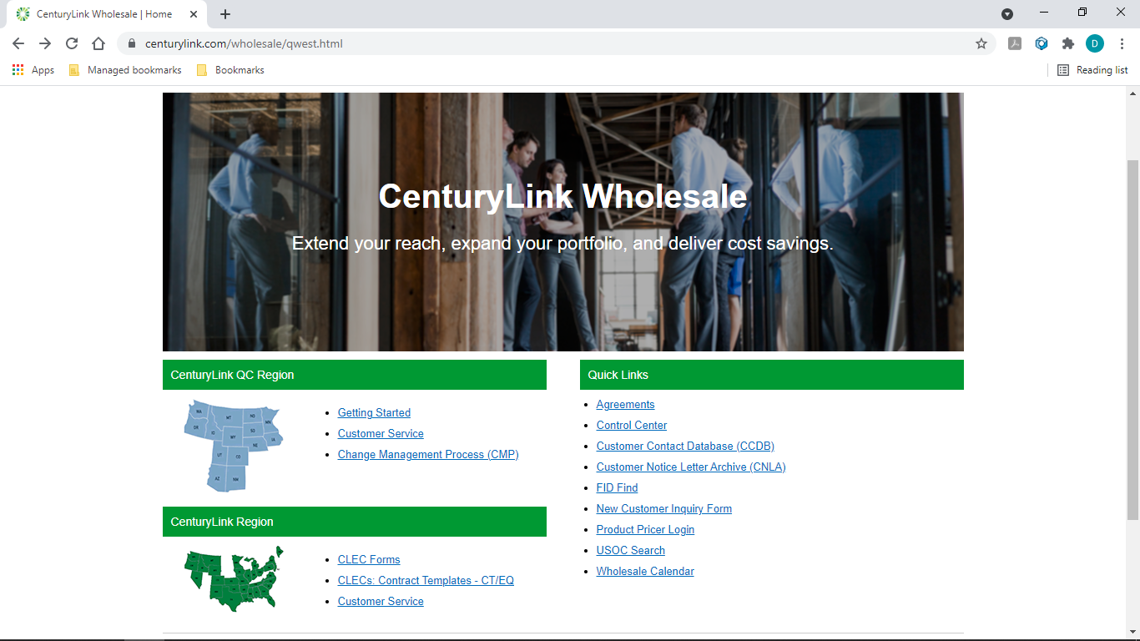
Select “EASE Training”
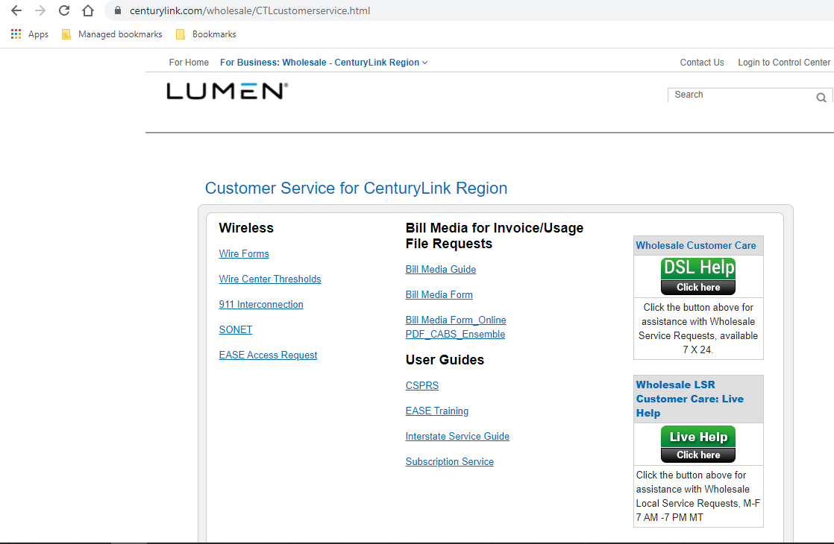

Select “Launch Training”

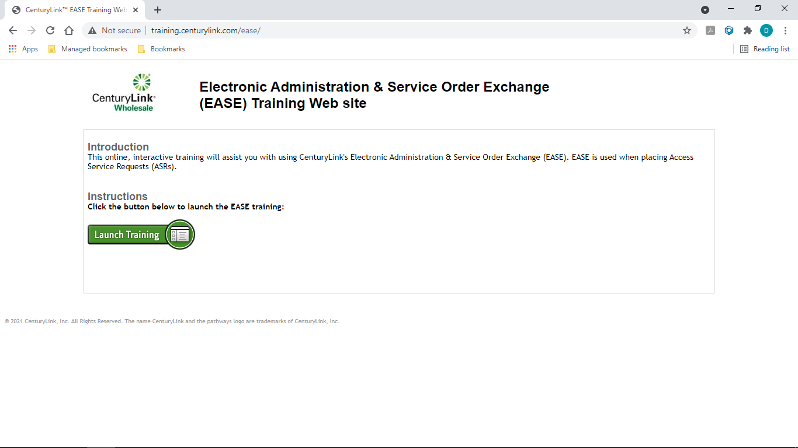

Select “Module 4: VFO Data Search” and then “VFO Order History”
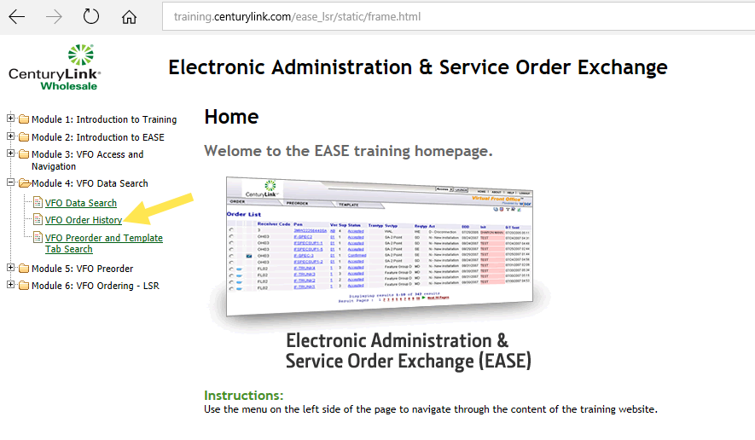
The training module will bring up a sample completed PON. Scroll to the bottom and select “Simulation”.
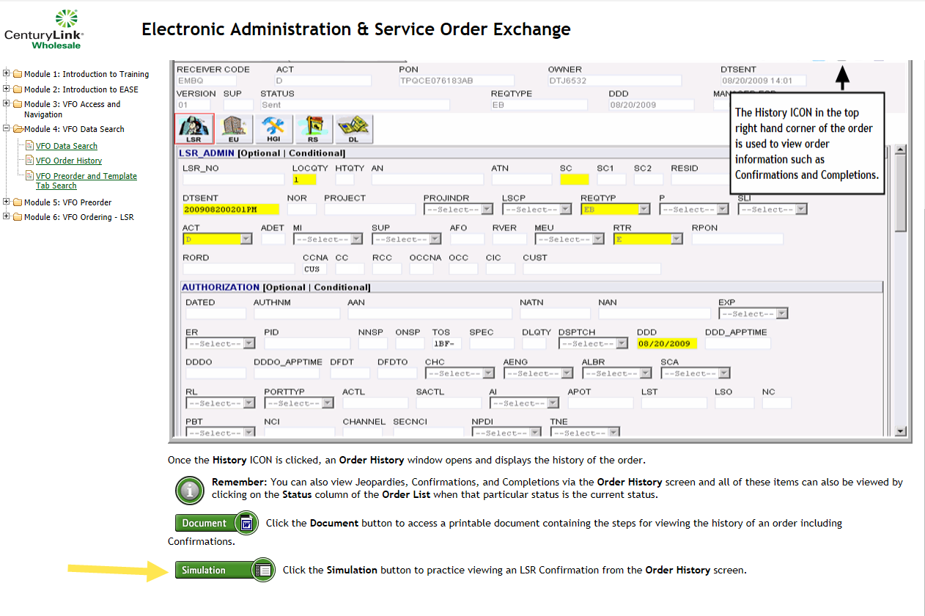

The following screen will appear. Select “Click Here to Begin”
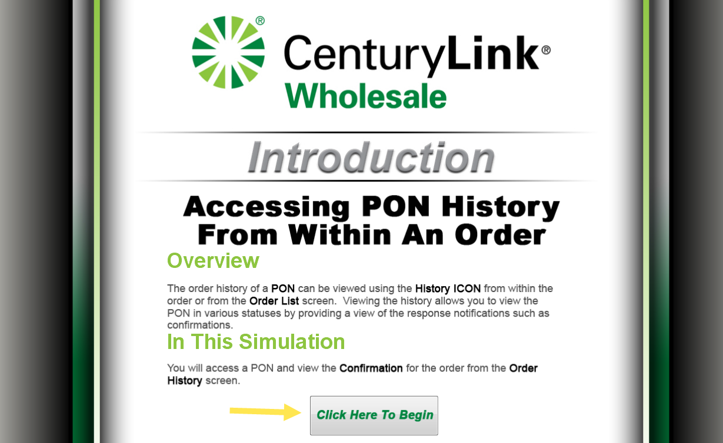
A simulation will open that looks like what a customer will see regarding its orders.
Once the PON has been completed please check EASE VFO Completion Status for the Static IP address.
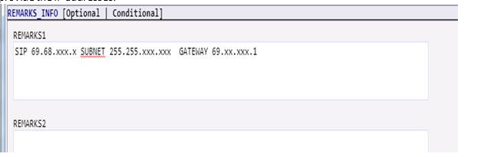
If one is not returned through EASE VFO then call the LSR Order Support at 866-434-2555 to obtain the Static IP addresses.

Static IP Validation

Central & Eastern Markets (legacy EQ/CT territory)
After the Static IP address is created in Legacy EQ/CT, validation is determined by “pinging” the addresses for validation.
The Customer will “ping” its network through the Static IP address determined in the steps above.
If you get a response, you know it’s a Redback device and the Static IP addresses should be configured at this point with no additional requirements from CTL
If it doesn’t ping, assume it’s a CBRAS device and the Static IP needs on site configuration. The Customer must not put the modem in bridge mode with CBRAS.
The Customer will then dispatch (for Step 1b) and finalize the configuration at the customer’s (end user’s) location to complete the Static IP set up. The link will guide them through the setup process: http://www.centurylink.com/home/help/internet/modems-and-routers/setup-cbras.html
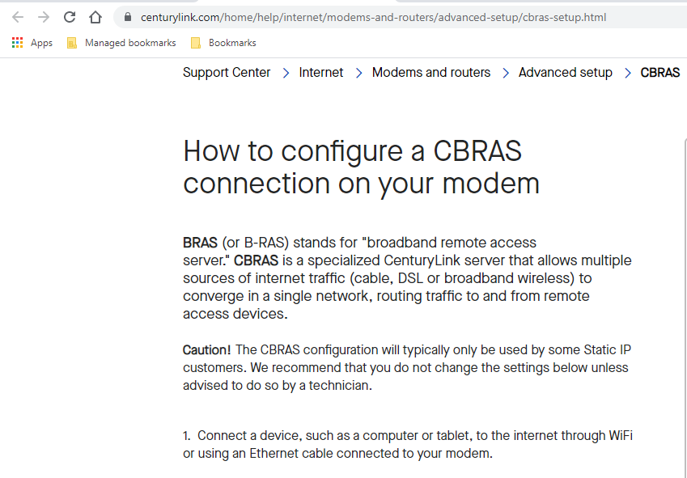

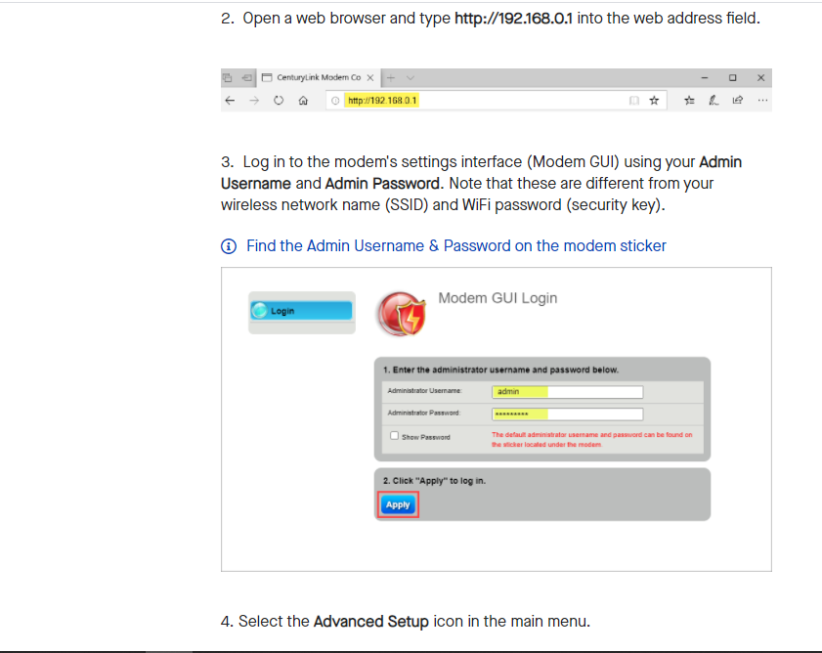
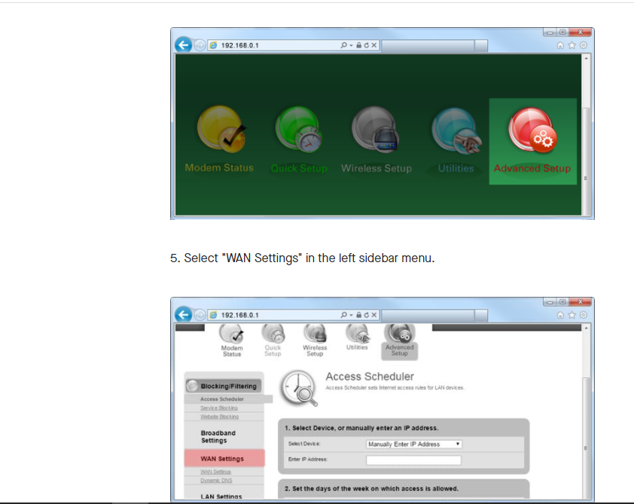
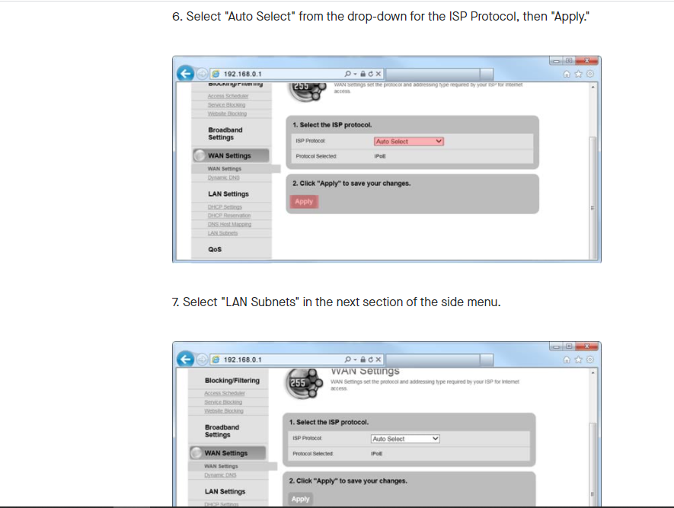

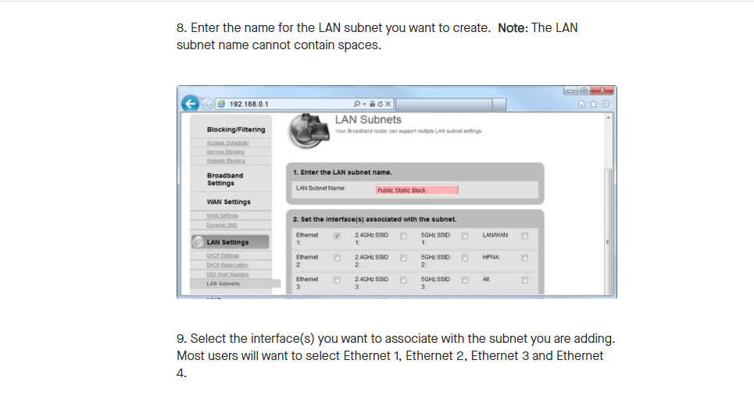

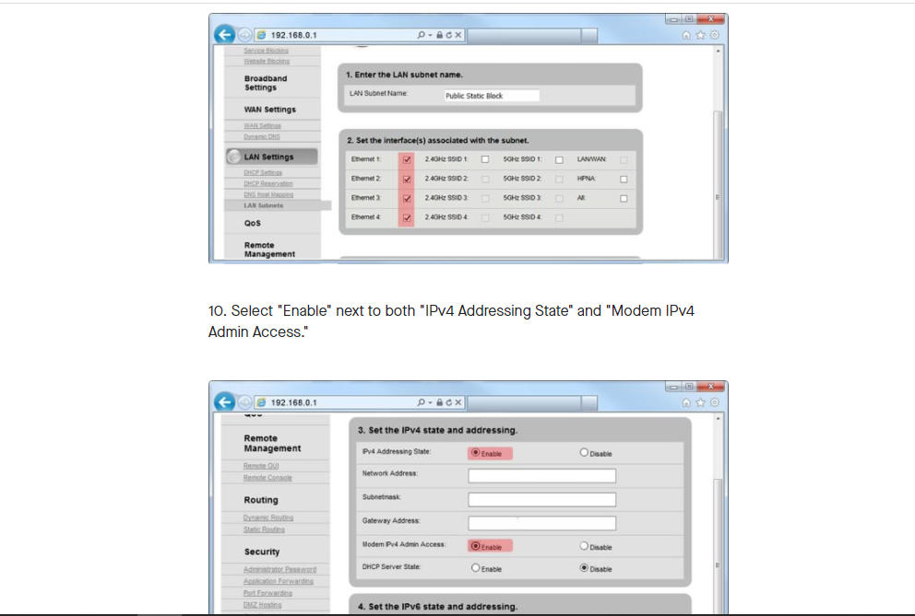

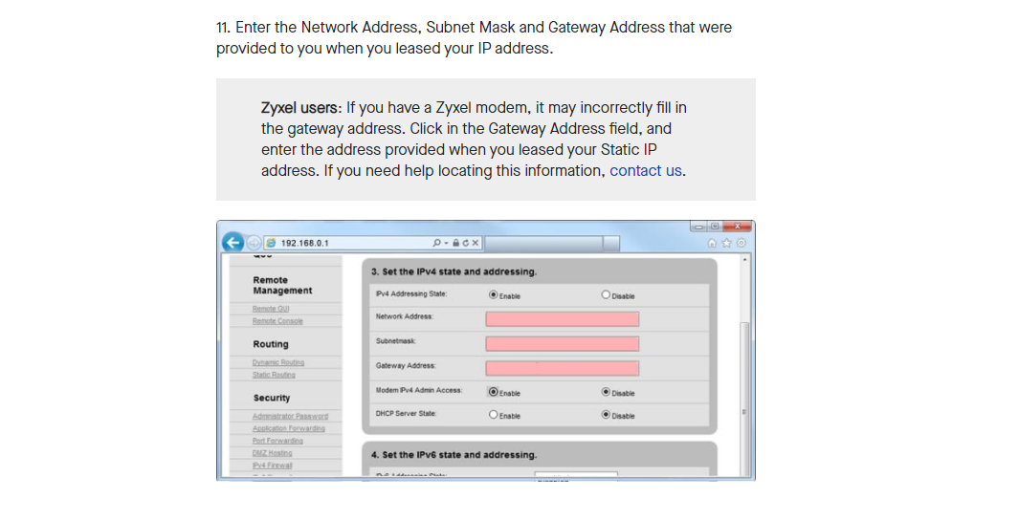

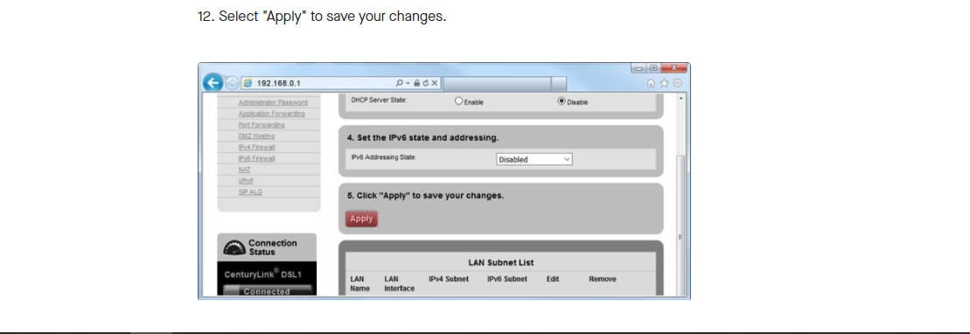

If there is a problem, the Customer needs to contact (not the Customer end user) the Repair Center for assistance. The information for DSL repair is located under the customer contacts:

Western Markets (legacy Q territory)
Legacy Q does not need additional validation.
WAN Interface and Customer LAN Setup (Customer Setup)
The Static IP set up document establishes the ordering of the addresses. Once ordered, CenturyLink will make them available via the WAN interface. The steps below show how to manage through the LAN interface for customer specific set up.
Configuring Static IP (single or block)
Type ctlhelp.com in your browser
Select “Modems/Routers” 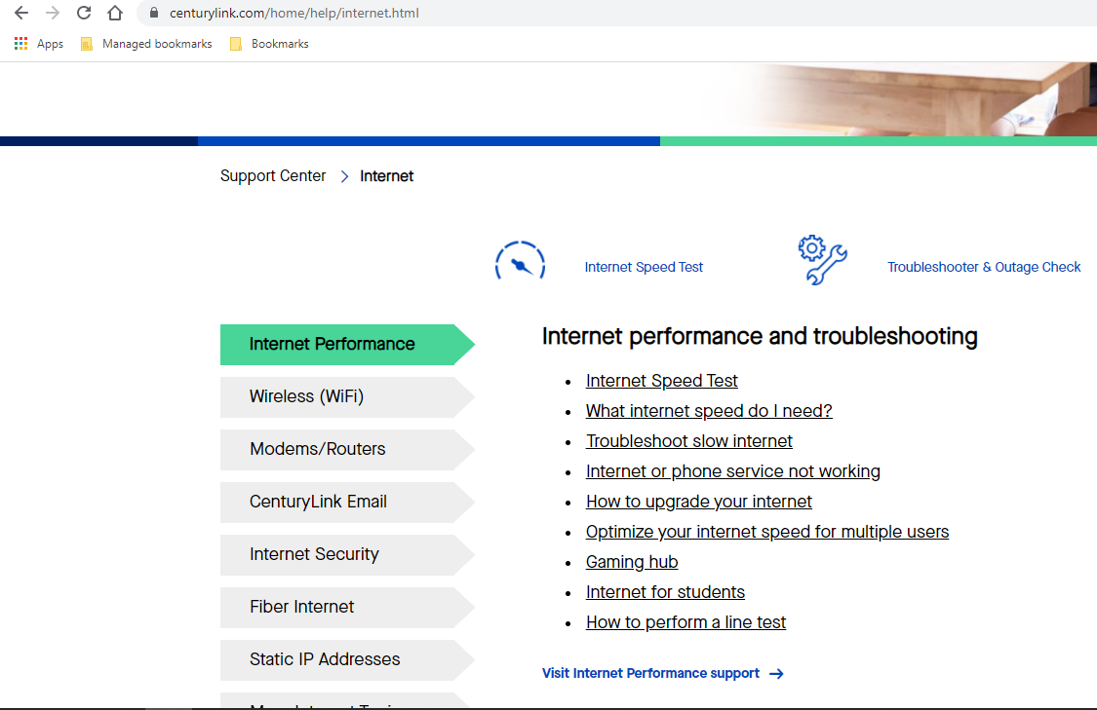
When the page opens, “Modem Setup” and select your modem (C4000 Series modem setup guide). Please note that the WBSA contract uses three modem variations, but the WAN set up is the same for each. The C4000BG is for example purposes only.

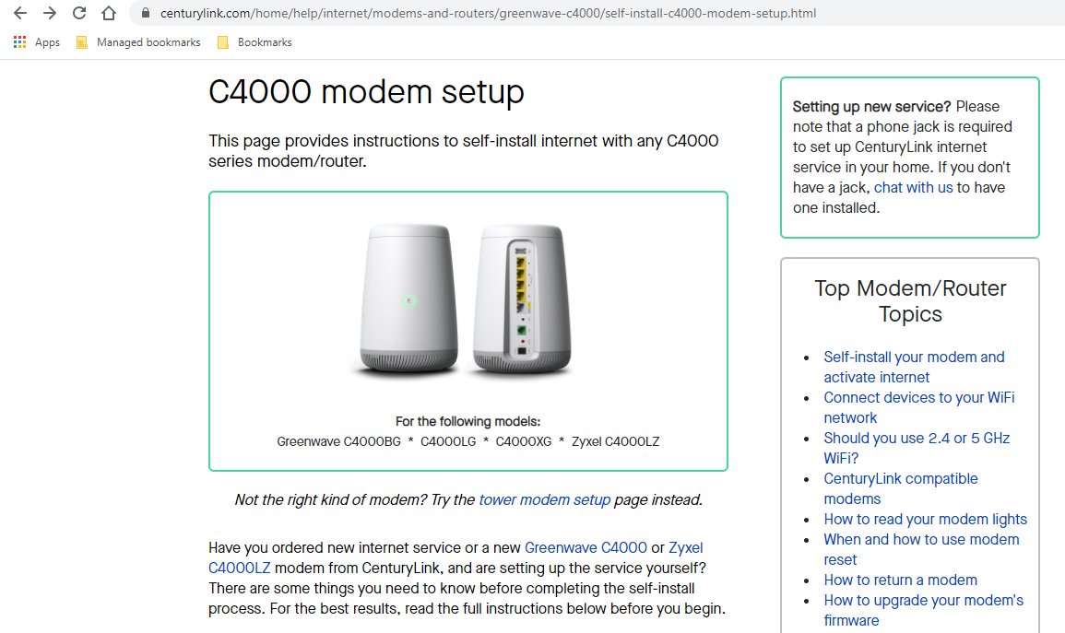

The modem specific set up page will open and provide answers to a variety of questions.

Select “Modem Setup” and then “WAN setup page”
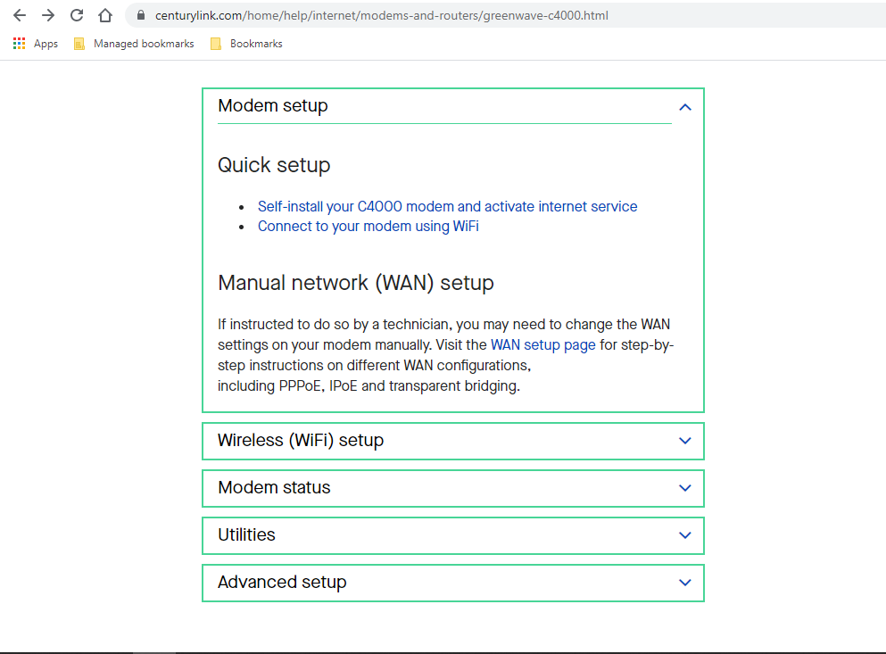

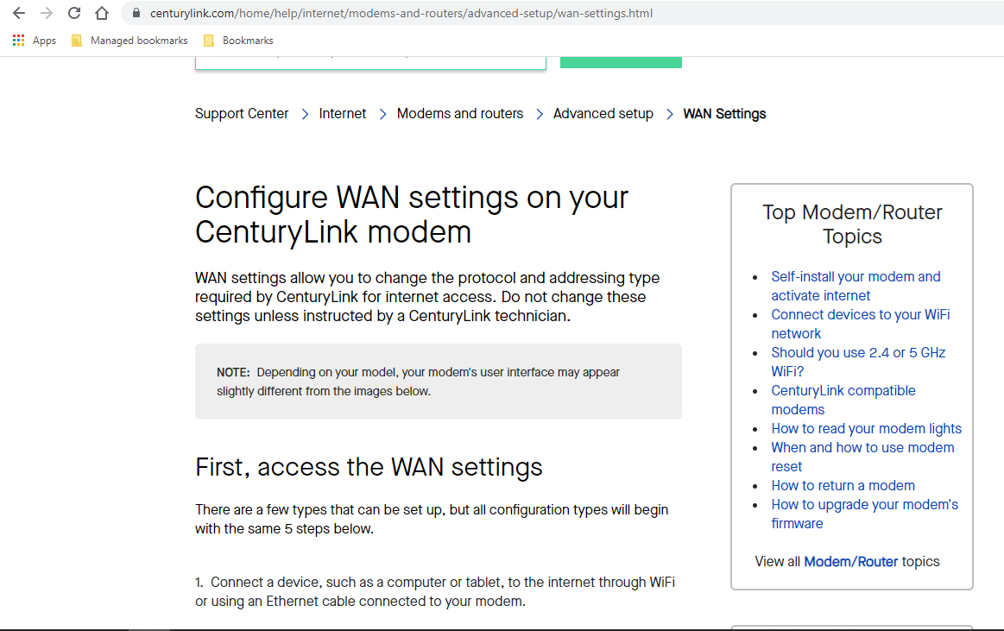
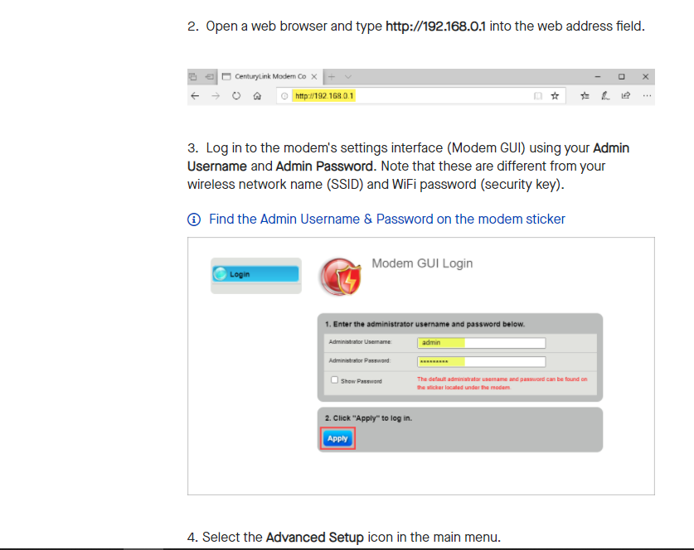
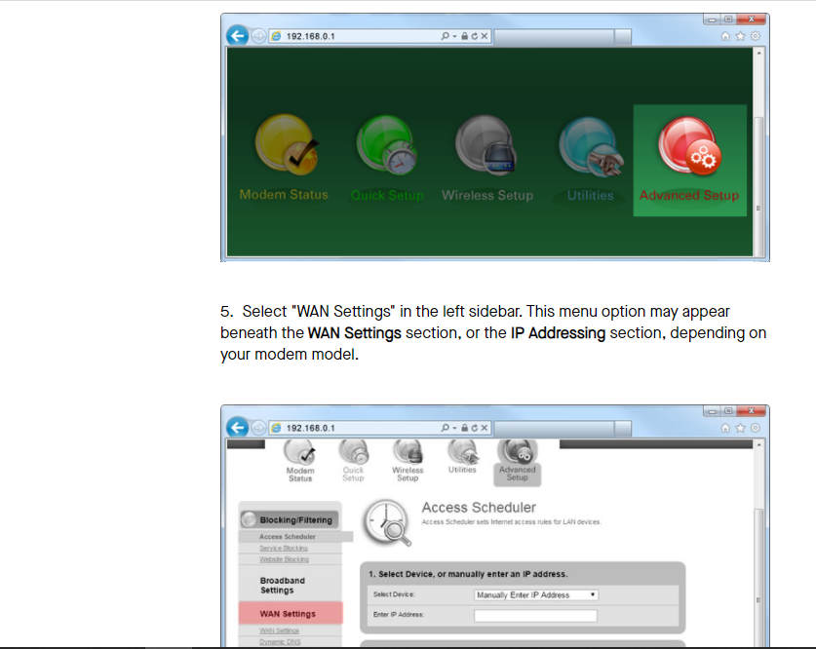
For this example, we have selected a Static IP block. The directions are similar for a single or block of addresses.

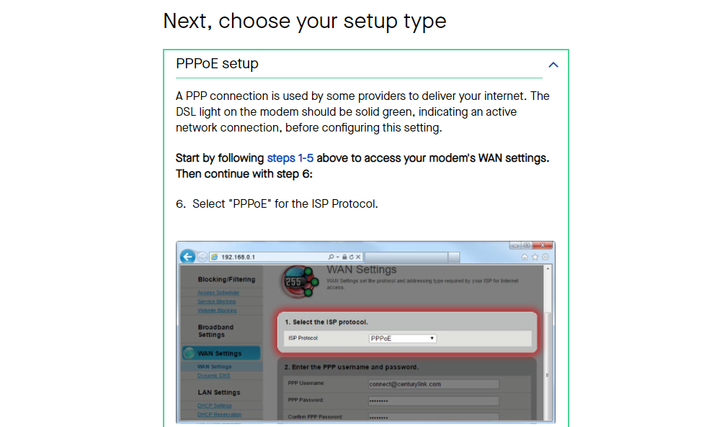

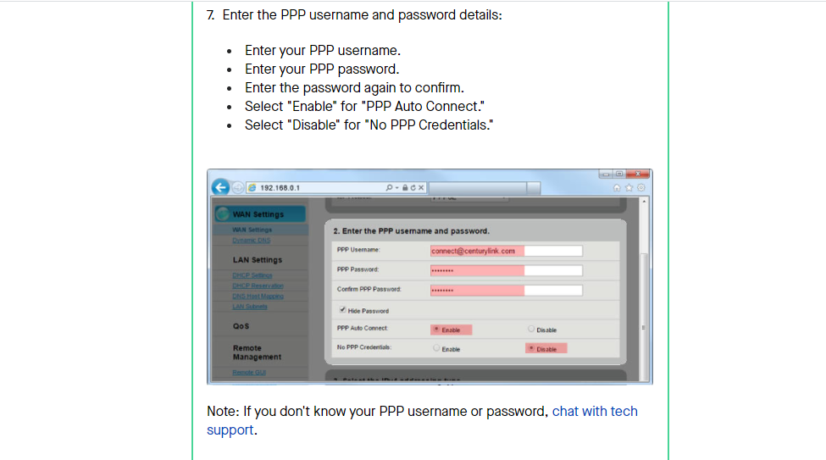
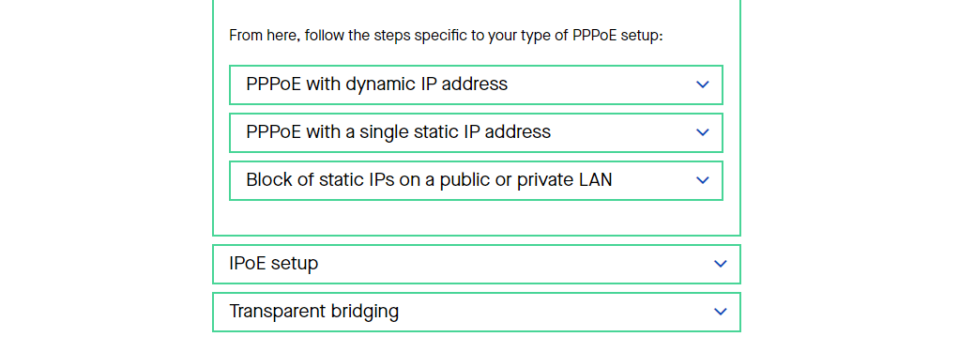

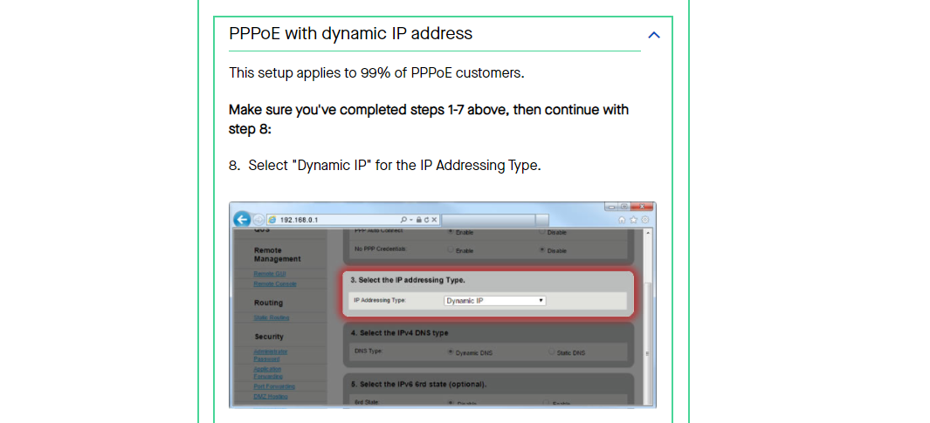
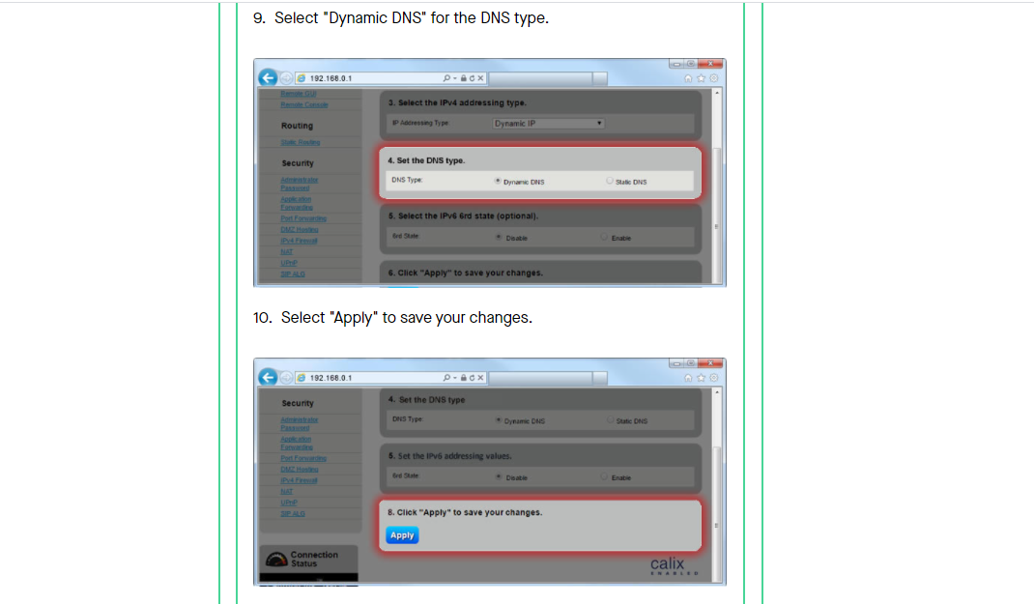

Please note that the username and password were created in the initial provisioning section.

Moving Locations and Static IP Impacts

Central & Eastern Markets (legacy EQ/CT territory)
Wholesale to Wholesale
When a customer places a “Move” order in the EASE system, the Center analyst will review all the services associated to the account and assure that those services move to the new location.
If the order stays within the same serving DSLAM/CBRAS device, the customer will keep the same Static IP addresses. When the order is installed by the technician, the processes identified in the previous sections will occur and the CenturyLink technician will make the Static IP addresses available up the WAN side of the customer location. The customer will then configure its LAN as done at the previous location and complete the move order.
If the order is no longer supported by the current DSLAM/CBRAS device, CenturyLink will work through the order and create new Static IPs to match the amount previously provisioned. These Static IPs will be available to view through order confirmation by the customer as well as available to the technician during the installation up to the WAN. The customer would then configure them on its LAN side as normal.
Retail to Wholesale
Retail accounts have an option to “share” a line with voice and data. Conversions follow the paths described here:
- Retail would issue an Ensemble C (Change) order on the pots line to remove HSI only and leave the voice.
- Or Ensemble D (disc) order on the pots line to remove both HSI and voice.
- Then there is a 2nd order -D (disc) order to be issued on the Web Access product.
In these cases, the Wholesale customer will need to place orders for Static IP addresses on the LSR and create new ones for the Wholesale customer. That ordering process is described in the previous document sections.

Western Markets (legacy Q territory)
Wholesale to Wholesale
When the customer is moving within the local area and their TN is not changing, then the Static IP can also be moved without any problems. When the customer is moving outside their current LATA (see the list below), the Static IP will need to change. For example, the old address has the ISP name of USWNETDNVR (Denver LATA 656). If the customer is moving to Colorado Springs (LATA 658), then the customer would need to return their current Static IPs and request new ones under the new username/password. Returning Static IP addresses occurs when the disconnect order is placed to move to the new LATA.
Retail to Wholesale
Retail to Wholesale conversions require disconnect and new orders which will create new TNs. Because the TN has the associated Static IP address, new Static IP requests must be made.
LATAs
MEGACENTNM | LATA | CITY AREA | STATE
Uswnetphnx | 666 | Phoenix | AZ
Uswnettcsn | 668 | Tucson | AZ
Uswnetclsp | 658 | Colorado Springs | CO
Uswnetdnvr | 656 | Denver | CO
Uswnetbois | 652 | Boise | ID
Uswnetcdrr | 635 | Cedar Rapids | IA
Uswnetdesm | 632 | Des Moines | IA
Uswnetdvnp | 634 | Davenport | IA
Uswnetsxcy | 630 | Sioux City | IA
Uswnetdlth | 624 | Duluth | MN
Uswnetmpls | 628 | Minneapolis | MN
Uswnetroch | 620 | Rochester | MN
Uswnetstcd | 626 | St Cloud | MN
Uswnetbzmn | 650 | Bozeman | MT
Uswnetmssl | 648 | Missoula | MT
Uswnetgdis | 646 | Grand Island | NE
uswnetomah | 644 | Omaha | NE
Uswnetsxfl | 640 | Sioux Falls | SD
Uswnetalbq | 664 | Albuquerque | NM
Uswnetbsmr | 638 | Bismarck | ND
Uswnetfarg | 636 | Fargo | ND
Uswneteugn | 670 | Eugene | OR
Uswnetptld | 672 | Portland | OR
Uswnetslkc | 660 | Salt Lake City | UT
Uswnetspkn | 676 | Spokane | WA
Uswnetsttl | 674 | Seattle | WA
Uswnetchyn | 654 | Cheyenne | WY

